‘SHMITA FOODS’ SEDER
A festive meal to honor and celebrate the food traditions of the Sabbatical Year

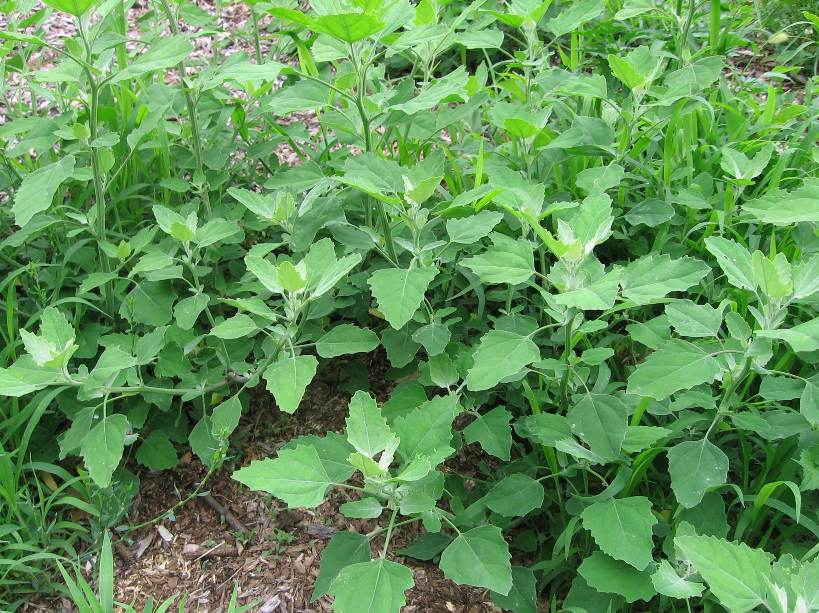 | 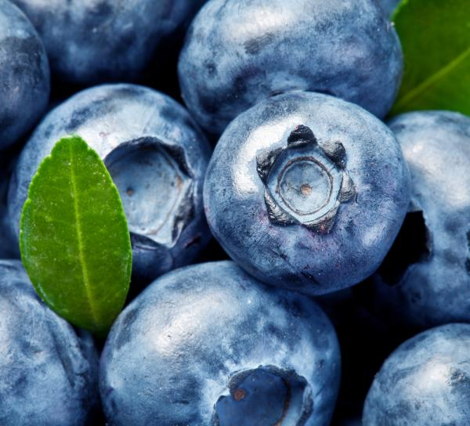  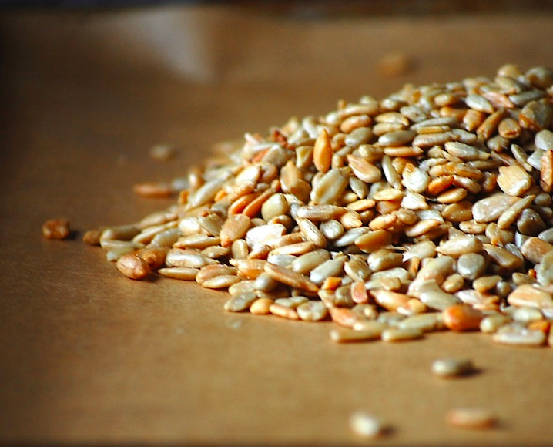
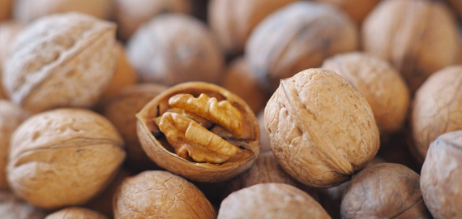 | 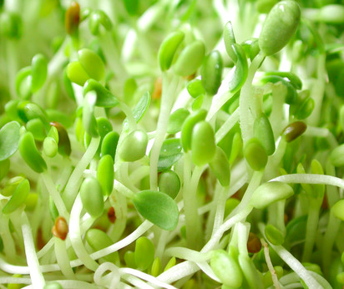  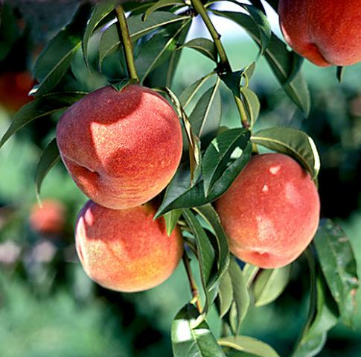

‘Shmita Foods’ Seder
First Edition
August 2013 / Elul 5773

Seder created by Yigal Deutscher, Manager of the Shmita Project
With thanks to Mirele Goldsmith, Director of the Jewish Greening Fellowship, for the inspiration
For further information and contact details:
www.hazon.org/shmitaproject
shmitaproject@hazon.org

SEDER INTRODUCTION:

The Jewish year contains many ritual meals, the paradigmatic one being the Passover Seder. These meals are designed to include rituals, song, prayer, and text, creating a focused attention for a particular thematic journey. These meals are powerful opportunities to engage our hearts, bodies, and minds, while sharing in food and exploratory conversation.

There is a Jewish tradition that every single meal should include words of Torah and thanksgiving:

R. Yohanan and Resh Lakish both explain: At the time when the Temple stood, the altar used to make atonement for a person; now a person’s table makes atonement for him.
Babylonian Talmud, Chagigah 27a

The theme of this Seder is Shmita, a biblical tradition of rest and release. Similar to the weekly Shabbat, but on an annual counting, Shmita is the final year of a seven year calendar cycle. Many may have heard of Shmita as the year when agricultural lands were collectively left fallow. Take a moment to realize just how radical and audacious that sounds. As an equivalent, since most of us are not farmers in this age, imagine a year when every shopping mall and bank would be closed, or a year when everyone would stay home from work. How might that sound to you?
The Shmita year had a depth that reached into every aspect of society and culture. This was only an ‘agricultural’ year in the sense that it directly involved food and land, something which would affect every one of us, not just farmers. If we were really celebrating this tradition, here is how it would look: On the final year of a seven year calendar cycle, there will be no seeding or tilling of the soil, private land holdings will be open to the commons, everyone will have equal access to food storage and perennial/wild harvests, foods will not be sold as a commodity, and all debts will be forgiven. Everyone will share in widespread abundance, as resources are redistributed and shared equally. Repeat this all again seven years later, and on every seventh year that follows.

The next Shmita year starts with Rosh Hashanah 2014 and continues until Rosh Hashanah 2015. Now that a significant percentage of the world Jewish population once again resides in Israel, the attention on Shmita is rising, and efforts are growing to reclaim our relationship with this tradition, not simply as a calendar year applicable only in Israel, or as a romantic symbol of utopian nostalgia, but as a portal into a lifestyle and holistic value system with potent wisdom for Jewish communities worldwide, widely applicable today.

We are excited to use the Seder model as a way to engage with and further explore this Shmita tradition. Our hope is that this will allow Shmita learning to happen in a lively manner, within groups of family and friends, while feeding and nourishing those relationships. Ideally, the Seder will have ripples beyond just thinking about the Shmita year, and it will inspire systematic thinking about our societal and personal food systems for all years. The Seder is simply a framework and outline. Feel free to adapt this according to your own interests, time, and needs.

May it be playful, nourishing, and educational!

OPENING:
Before you begin your Seder, take a moment to explore these texts below, which introduce Shmita from the biblical perspective, and will help frame the Seder to follow. This would be a great opportunity to open the space with the blessing for fruits of the vine (below), and to enjoy a glass of wine to accompany these words of Torah.
א וַיְדַבֵּר יְהוָה אֶל-מֹשֶׁה, בְּהַר סִינַי לֵאמֹר. ב דַּבֵּר אֶל-בְּנֵי יִשְׂרָאֵל, וְאָמַרְתָּ אֲלֵהֶם, כִּי תָבֹאוּ אֶל-הָאָרֶץ, אֲשֶׁר אֲנִי נֹתֵן לָכֶם וְשָׁבְתָה הָאָרֶץ, שַׁבָּת לַיהוָה. ג שֵׁשׁ שָׁנִים תִּזְרַע שָׂדֶךָ, וְשֵׁשׁ שָׁנִים תִּזְמֹר כַּרְמֶךָ; וְאָסַפְתָּ, אֶת-תְּבוּאָתָהּ. ד וּבַשָּׁנָה הַשְּׁבִיעִת, שַׁבַּת שַׁבָּתוֹן יִהְיֶה לָאָרֶץ שַׁבָּת, לַיהוָה: שָׂדְךָ לֹא תִזְרָע, וְכַרְמְךָ לֹא תִזְמֹר.
ה אֵת סְפִיחַ קְצִירְךָ לֹא תִקְצוֹר, וְאֶת-עִנְּבֵי נְזִירֶךָ לֹא תִבְצֹר: שְׁנַת שַׁבָּתוֹן, יִהְיֶה לָאָרֶץ. ו וְהָיְתָה שַׁבַּת הָאָרֶץ לָכֶם, לְאָכְלָה לְךָ, וּלְעַבְדְּךָ וְלַאֲמָתֶךָ; וְלִשְׂכִירְךָ, וּלְתוֹשָׁבְךָ, הַגָּרִים, עִמָּךְ. ז וְלִבְהֶמְתְּךָ-וְלַחַיָּה, אֲשֶׁר בְּאַרְצֶךָ: תִּהְיֶה כָל-תְּבוּאָתָהּ, לֶאֱכֹל.
1 The Lord spoke to Moshe at Mount Sinai, saying: 2 Speak to the Children of Israel, and say to them: When you enter the land that I am giving you, the land is to cease, and observe a Sabbath to the Lord. 3 For six years you are to sow your field, for six years you are to prune your vineyard, then you are to gather in its produce, 4 but in the seventh year the land shall have a complete rest, a Sabbath to the Lord: your field you are not to sow, your vineyard you are not to prune, 5 the after-growth of your harvest you shall not reap, the grapes of your untrimmed vines you shall not amass; it shall be a year of complete rest for the land! 6 And the produce of the Shabbat of the land shall be yours to eat: for you, for your servant and for your handmaid, for your hired-hand and for your resident-settler who sojourn with you; 7 and for your domestic-animal and the wild-beast that are in your land shall be all its produce, to eat.
Leviticus 25.1-7

And the after-growth of your harvest you shall not reap: With the intention of taking possession and ownership of it, like other harvests. Rather it shall be hefker [ownerless] for all to take freely. (RASHI)
And the produce of the Shabbat of the land shall be yours to eat: Although I have prohibited the produce of the Shmita year to you, I did not prohibit you from eating it or deriving benefit from it- only that you should not treat it as its owner. Rather all should have equal rights to the produce of the seventh year, you, your hired worker, and those who reside with you. (RASHI)

- What is the significance of allowing a land to ‘rest’? What impacts would this have on a society and ecosystem if all farmers took a year of fallow together? What would the benefits & challenges be?
- If food could not be ‘owned’, then it could not become a private commodity, to be bought and sold in the marketplace. How might your perspective of food change once it no longer had a price tag? How much of your relationship to food is determined by its price?
- If you would not be able to purchase your produce at the market, what are other ways would you ensure access to food? What systems would need to be in place to support local food security?
- What ways might you consider expanding fair and healthy food access for all peoples, inspired by Shmita-values?
Barukh atah Adonai Eloheinu Melekh ha'olam, bo're p'ri ha'gafen.  Blessed are You, Lord our G!d, Master of the Universe, Who creates the fruit of the vine. | הפן פרי בורא העולם מלך אלהנו יי אתה ברוך
BLESSING:
As you further enter into this space of intentional, mindful, and celebratory eating, here is a text to explore together, abut the nature of food, blessings and faith, from the perspective of Shmita:
יח וַעֲשִׂיתֶם, אֶת חֻקֹּתַי, וְאֶת-מִשְׁפָּטַי תִּשְׁמְרוּ, וַעֲשִׂיתֶם אֹתָם-וִישַׁבְתֶּם עַל-הָאָרֶץ, לָבֶטַח. יט וְנָתְנָה הָאָרֶץ פִּרְיָהּ, וַאֲכַלְתֶּם לָשֹׂבַע; וִישַׁבְתֶּם לָבֶטַח, עָלֶיהָ. כ וְכִי תֹאמְרוּ, מַה-נֹּאכַל בַּשָּׁנָה הַשְּׁבִיעִת: הֵן לֹא נִזְרָע, וְלֹא נֶאֱסֹף אֶת-תְּבוּאָתֵנוּ. כא וְצִוִּיתִי אֶת-בִּרְכָתִי לָכֶם, בַּשָּׁנָה הַשִּׁשִּׁית; וְעָשָׂת, אֶת-הַתְּבוּאָה, לִשְׁלֹשׁ, הַשָּׁנִים. כב וּזְרַעְתֶּם, אֵת הַשָּׁנָה הַשְּׁמִינִת, וַאֲכַלְתֶּם, מִן-הַתְּבוּאָה יָשָׁן; עַד הַשָּׁנָה הַתְּשִׁיעִת, עַד-בּוֹא תְּבוּאָתָהּ-תֹּאכְלוּ, יָשָׁן.

18 You shall observe my laws, and you shall guard my laws, and observe them, that you may live on the land in security. 19 The land shall give forth its fruit and you shall eat your fill, and be settled upon it in security. 20 And if you should say to yourselves: What are we to eat in the seventh year,
if we may not sow, nor may we gather in our produce? 21 Then I will ordain my blessing for you during the sixth year so that it shall yield a crop sufficient for three years. 22 When you sow your seeds in the eighth year, you shall still be eating of the old produce; you shall be able to eat what-is-old until the ninth year, until its crops come in.
Leviticus 25.18-22

- How much of your relationship to food is based on faith that there will be enough?
- Do you think of God, or forces beyond-human, when you think of your food sources and sustenance?
- How much of a blessing practice do you have in your own food consumption?
- If you were preparing for the arrival of Shmita, what types of emotions do you think would arise for you? Would you be concerned that your most basic needs might not be met? Or might you have faith these needs would indeed be met?

As you prepare to enjoy the Seder foods, begin with a shared blessing, both for the fruits of the tree and for the foods of the land.
After the blessing, begin with the first section of the Seder, on the following page.

Barukh atah Adonai Eloheinu Melekh ha'olam, bo're p'ri ha'eytz  Blessed are You, Lord our G!d, Master of the Universe, Who creates the fruit of the tree. | העץ פרי בורא העולם מלך אלהנו יי אתה ברוך
Barukh atah Adonai Eloheinu Melekh ha'olam, bo're p'ri ha'adamah.  Blessed are You, Lord our G!d, Master of the Universe, Who creates the fruit of the earth. | האדמה פרי בורא העולם מלך אלהנו יי אתה ברוך

- WILD & PERENNIAL HARVEST:  Rambam, Hilchot Shmita v’Yovel 4.1-3  הַא לָמַדְתָּ, שְׁאֵין אוֹכְלִין מִפֵּרוֹת שְׁבִיעִית אֵלָא פֵּרוֹת הָאִילָנוֹת, וְהָעֲשָׂבִים שְׁאֵין זוֹרְעִין אוֹתָם רֹב הָאָדָם, כְּגוֹן הַפֵּיגָם וְהַיַּרְבוּזִין הַשּׁוֹטִים וְכָל כַּיּוֹצֶא בָּהֶן.  We have learned that the only produce of the Shmita year of which one may partake are the harvest of fruit trees and vines, as well as wild plants that are not typically sown in a garden, such as rue, amaranth, and the like.  - What do you think the benefits may have been- for the body and the land- in consuming such foods for a year? Do you think you would be able to sustain yourself on a diet of perennial, wild or uncultivated foods?  - Perennial: Have you thought of this food as a perennial before? What makes it different than foods from an annual plant? Are such foods balanced in your own eating preferences and habits?  - Wild: What might be the differences between this wild food and a similar cultivated variety? Have you ever harvested this food or other similar foods from the wild before? What was that experience like for you? | - SEASONAL FOODS:  Rambam, Hilchot Shmita v’Yovel 7.1  פֵּרוֹת שְׁבִיעִית אֵין אוֹכְלִין מֵהֶן אֵלָא כָּל זְמָן שֶׁאוֹתוֹ הַמִּין מָצוּי בַּשָּׂדֶה . . . כָּל זְמָן שֶׁחַיָּה אוֹכֶלֶת מִמִּין זֶה מִן הַשָּׂדֶה, אַתָּה אוֹכֵל מִמַּה שֶׁבַּבַּיִת; כָּלָה לַחַיָּה מִן הַשָּׂדֶה חַיָּב לְבַעַר אוֹתוֹ הַמִּין מִן הַבַּיִת.  We may only partake of the produce of the Sabbatical year as long as that species is still found growing in the field…As long as an animal can be eating from this species in the field, one may eat from what he has collected at home. When there is no longer any of that species for the animal to eat in the field, one is obligated to remove that species from his home (and make it available for public consumption, until it is finished).  - How do you understand this connection between the eating patterns of animals and humans, in regards to seasonality?  - How challenging or easy is seasonal eating in the climate you live in? If you are not growing your own food, how do you generally find out if food is in season? What foods do you associate with this season we are now in?  - How would you preserve harvests through the full-duration of the season?
- LOCAL DIET:  Rambam, Mishne Torah, Hilchot Shmita v’Yovel 5.13  פֵּרוֹת שְׁבִיעִית אֵין מוֹצִיאִין אוֹתָן מֵהָאָרֶץ לְחוּצָה לָאָרֶץ, וְאַפִלּוּ לְסוּרְיָה.  The produce of the Sabbatical year may not be transported from the land of Israel to anyplace outside the land, not even to Syria [neighboring country].  - In the United States, food travels 1,500 miles, on average, from farm to consumer. How far do you think these foods you are now eating have traveled? How close should a food be grown, for you to consider it ‘local’?  - What type of agricultural and economic systems would need to be in place to ensure a vibrant local ‘foodshed’ (total geographic area where your food is grown)? What would be the benefits and challenges in relying on local food production?  - What is the most local, direct source for your own food needs? If you were eating a local diet, what foods would you have to compromise on? How would you seek creative alternatives for the foods you’d be missing? | - EAT RIPE:  Rambam, Mishne Torah, Hilchot Shmita v’Yovel 5.15  אֵין אוֹסְפִין פֵּרוֹת שְׁבִיעִית כִּשְׁהֶן בֹּסֶר-שֶׁנֶּאֱמָר "תֹּאכְלוּ, אֶת-תְּבוּאָתָהּ" (ויקרא כה,יב), אֵינָהּ נֶאֱכֶלֶת עַד שֶׁתֵּעָשֶׂה תְּבוּאָה. וְלֹא יִכְנֹס לֶאֱכֹל בְּתוֹךְ בֵּיתוֹ, עַד שֶׁיַּגִּיעוּ לְעוֹנַת הַמַּעַשְׂרוֹת.  We do not harvest the produce of the Sabbatical year when it is not yet ripe, as it says (Vayikra 25.12) “And you shall partake of its produce,” implying that the fruits may not be eaten until they are considered as produce. One should not bring the produce into one’s home until it reaches the stage when the obligation to separate tithes takes effect [marking its ripeness].  - Do you agree with this statement that until a fruit is fully ripe, it cannot truly be considered as produce? Compare the sensory impression, aroma & flavor of the food you are now eating against biting into a greenish, unripe peach. Consider the nutrient richness of a ripe food, as well. How might this be different than the nutrients before ripeness?  - What might be some of the challenges for allowing fruit to ripen on the plant? Why do you think there might be a strong preference to harvest produce before full ripeness, in large-scale farm systems?
GRATITUDE/VISION:
As a last stage to your Seder, take a moment for gratitude and appreciation. Explore this text below to see the vision of blessings that may come about with honoring and celebrating the values of the Shmita year:
ב אֶת שַׁבְּתֹתַי תִּשְׁמֹרוּ, וּמִקְדָּשִׁי תִּירָאוּ: אֲנִי, יְהוָה. ג אִם-בְּחֻקֹּתַי, תֵּלֵכוּ; וְאֶת-מִצְו‍ֹתַי תִּשְׁמְרוּ, וַעֲשִׂיתֶם אֹתָם. ד וְנָתַתִּי גִשְׁמֵיכֶם, בְּעִתָּם; וְנָתְנָה הָאָרֶץ יְבוּלָהּ, וְעֵץ הַשָּׂדֶה יִתֵּן פִּרְיוֹ. ה וְהִשִּׂיג לָכֶם דַּיִשׁ אֶת-בָּצִיר, וּבָצִיר יַשִּׂיג אֶת-זָרַע; וַאֲכַלְתֶּם לַחְמְכֶם לָשֹׂבַע, וִישַׁבְתֶּם לָבֶטַח בְּאַרְצְכֶם. ו וְנָתַתִּי שָׁלוֹם בָּאָרֶץ, וּשְׁכַבְתֶּם וְאֵין מַחֲרִיד; וְהִשְׁבַּתִּי חַיָּה רָעָה, מִן-הָאָרֶץ, וְחֶרֶב, לֹא-תַעֲבֹר בְּאַרְצְכֶם...יב וְהִתְהַלַּכְתִּי, בְּתוֹכְכֶם, וְהָיִיתִי לָכֶם, לֵאלֹהִים; וְאַתֶּם, תִּהְיוּ-לִי לְעָם. יג אֲנִי יְהוָה אֱלֹהֵיכֶם, אֲשֶׁר הוֹצֵאתִי אֶתְכֶם מֵאֶרֶץ מִצְרַיִם, מִהְיֹת לָהֶם, עֲבָדִים; וָאֶשְׁבֹּר מֹטֹת עֻלְּכֶם, וָאוֹלֵךְ אֶתְכֶם קוֹמְמִיּוּת.
2 My Sabbaths you are to keep, my Holy-Shrine you are to hold-in-awe, I am the Lord! 3 If you follow in the ways of my laws, and my commandments you guard, and observe them, 4 then I will give-forth your rains in their season, so that the earth shall yield its produce and the trees of the field their fruit. 5 Your threshing shall overtake the vintage, and your vintage shall overtake the sowing; you shall eat your food to full satisfaction, and be settled in security in your land. 6 I will give peace throughout the land, so that you will lie down with none to make you tremble…12 I will walk about in your midst, I will be for you as a G!d, and you yourselves will be for me as a people. 13 I the Lord am your G!d who brought you out of the land of Egypt, from your being slaves to them; I broke the bars of your yoke, enabling you to walk upright!
Leviticus 26.2-6, 12-13

- What are the specific points of the blessing that comes with observing the Shabbat moments in time? Is this a landscape you can envision for yourself and your community?
- Why do you think it is the symbol of the ‘Sabbaths’ (Shabbat and Shmita) that are highlighted as the portal to bring about such abundance?
- What practices of gratitude and appreciation do you have for all the blessings already in your life?

What are the main values and ideals of the Shmita food tradition?

How can we use these values to guide us in designing healthy systems of food production and consumption today?
How can we begin creating diverse, perennial, edible abundance for ourselves, and our local community landscapes?

UNDERSTANDING SHMITA FOODS:
Along with the opportunity to share in the company of friends and enjoy the abundance of healthy foods, the hope in creating this educational experience is to provide a portal in which to deepen into a personal relationship with the food traditions of the Shmita year. If the Seder creates as many questions as answers, that would be wonderful. In the ideal sense, the Seder will work to stimulate your curiosity as well as your taste buds. There is much complexity around the idea of Shmita foods, with many layers to explore.

At its most basic level, the Shmita year was a time for leaving agricultural fields fallow: there would be no seeding and no plowing of farmlands. The direct impact was that no annual plants would be grown during this year. Annual plants are those that live their life cycle of seed-to-seed in one growing season. An example of this would be a cucumber or lettuce. These are planted in the spring and, by the summertime, the cucumber (fruit body full of seed) has fully formed, and the head of lettuce, if not harvested, continues to grow, creating a long seed-stalk. Annuals tend to have very short life spans, and produce seed within 2-4 months. These plants use the nutrients of the sun, water and soil to create a heavy, lush body as fast as they can; and the larger the body, the more flowers; and the more flowers, the greater chance of pollination and eventual seeds. After the next generation of seeds (thousands of them) have been formed, the ‘mother’ plant begins to dry out and die back. Such annual plants include all of our grains, legumes, and most of our common leafy greens and vegetables.

So what would we be eating if not for these foods? That would be any food-producing plant that does not require soil cultivation or seeding. These are the foods we have focused on in this Seder: perennial and wild plants. Perennials, unlike annuals, invest energy in strengthening their own body. While they are producing seeds, they are also developing woody trunks, branches, and roots. This allows the plant’s body to live for numerous years, and it makes the plants more resilient: with deep roots they can withstand drought and wind much better than annuals; with woody fiber they can withstand pest damage much better than annuals; and with seasonal die back of their own leaves and roots, they create their own pockets of decaying organic matter, which helps to enrich the soils around them and support symbiotic relationships with other soil organisms. Perennial plants are most of our tree and vine fruits, nuts, berries, and herbs.

Wild plants are either annual or perennial. What makes these plants unique is that they grow just fine without human support. All the food-plants we now cultivate in our farm and gardens were originally growing wild (and still are, in their native habitat). Through years of domestication and seed saving, we have ‘bred’ these plants so that the roots, leaves, seeds, and fruits will meet our desired flavors and sizes. With all the domestication we have done over the generations, there are still so many types of foods growing in the wild, not part of the common diet. Wild plants tend to have much richer levels of nutrients, because their roots have to mine deeper for their own survival, through soils that have not been cultivated. Also, with no irrigation provided, their bodies and fruits may be smaller, but their flavors are much more concentrated. Many wild plants are also strong in medicinal qualities. The awareness, understanding, and inclusion of wild plants (many varieties of leafy greens, herbs, and tree fruits) is critical in creating a full, healthy Shmita diet.

On the simplest level, we can leave it at this: Shmita foods are perennial and wild plants, which, based on further Rabbinic clarifications, must be harvested in season, when ripe, and be eaten locally. But there is much more to explore as we renew this tradition.

Let’s begin by considering plants that are neither annuals nor perennials. Such plants are biennials, and they live through two growing seasons. These plants, such as kale, collards and chard, have the ability to be planted in the spring and continue to grow, without producing seed, all the way until the end of the following spring season. These plants can be planted before Shmita begins, and thus can continue to grow during the Shmita year without a need for seeding or cultivation. Would these be considered Shmita foods?

The other plant category we might consider are a unique group of annuals that are called ‘self-seeders.’ These plants produce seeds that have an ability to easily grow where they naturally drop, without being sown by human hands, and without a soil bed being prepared for them. Tomatoes are arugula seeds have a tendency to naturalize and ‘volunteer,’ germinating in the garden as if they were wild plants, without a need for seeding or cultivation.

Both biennials and self-seeders are considered to be in the category of Sfichim. According to strict Rabbinical law, these foods should not be considered Shmita foods, and should not be eaten during the Shmita period. The Rabbis had a concern that people would continue seeding, growing, and harvesting these plants during the Shmita year in their own gardens, while proclaiming that they were in fact ‘volunteers’ or growth from an earlier crop planted before Shmita began.

Next, lets consider the garden planted right before the start of the Shmita year. Shmita begins in the Hebrew month of Tishrei, on the new year, Rosh Hashana. This usually comes out sometime in September. Potentially, if a garden was dug and planted in the late summer, before Rosh Hashana, this would likely provide some harvests for the early months of the Shmita year. However, the same Rabbinic concern (that folks would continue planting into the Shmita year) inspired a new ruling: that no soil could be cultivated or seeds sown starting 30 days prior to the official beginning of the Shmita year. Truth is, in Israel, agriculture was based on the rain cycle, and there was no seeding in the dry summer season, not 30 days before Shmita and not 60 days before Shmita. So it would be highly unlikely (in pre-irrigation farming) for there to have been any natural harvests during the Shmita year from annuals planted in the months before Rosh Hashana.

Yet another area of complexity around Shmita is food storage: Can we prepare for Shmita by preserving foods? On the one hand, we know that we were ideally meant to eat in the same rhythm as wild animals on this Shmita year, harvesting and eating only as long as such foods were still growing in their natural season, available to animals in the fields. On the other hand, we know that there was a promised blessing of abundant harvests in the sixth year of the Shmita cycle, which were meant to be put into storage and last all the way through the end of the Shmita year.

To understand this complexity, it is important to realize that the main annual plants grown agriculturally during biblical times were primarily grains and legumes. The promised abundance during the sixth year was specifically for these plants and their dry seeds, which could be stored through multiple seasons. Other forms of storage during biblical times were drying fruits, fermenting fruits into alcohol, and pressing olives into oil. Beyond this, there was likely not much of a reliance on long-term storage (roots, pickles, live fermentation), as this was a desert climate, before extended cold-storage technology was available. Once the Shmita year began, wild and perennial harvests could only be eaten in season. Once the season of natural growth ended for such a food, any portions of it that were still in personal storage (in fresh, dried, pickled, or fermented form) had to be made available to the community and shared together until such foods were finished.

So even with the Shmita dietary and agricultural restrictions, there still is flexibility on the foods of this year. From the widest perspective, you could include meat, dairy, poultry, and fish, and you could include bread and cooked grains/legumes. And, if you feel strongly about it, you could also choose to include ‘self-seeders’ and biennials, as well as vegetables planted before Rosh Hashana, to be harvested anytime during Shmita. For the sake of this Seder, however, the invitation is really for a purist perspective, with a focus on wild and perennial foods, as well as uncooked, unground seeds. It is not the intention for this to be an experience of scarcity, rather the opposite: hopefully, the more we can really focus on the simple abundance of these foods, the more we can begin to form deeper connections with them in our diet, and realize how much sustenance they do provide us. Also, these foods shift our focus from industrial agriculture and conventional food systems to the more wild origins of our foods and land relationships.

As a last point, you should realize that the idea of Shmita foods is specifically, and quite importantly, place-based. As Shmita foods must be harvested in season and eaten locally, to be able to fully grasp the Shmita foods of your own landscape, you must know your climatic seasons, your local farms, and the native plant ecology around you. In Israel, the land of origins for the Shmita tradition, the local ecology was naturally conducive for such a diet. This was a land blessed with the fertile, abundant growth of seven particular plants, the Shivat Minim: Grapes, Figs, Pomegranates, Dates, Olives, Wheat and Barley. Five of these plants are perennial fruit trees, and the other two are grains. Israel has an arid Mediterranean climate, with long dry summers and rainy winters. During the winter months, there would be lush green growth with many choices for wild edibles. During the Spring, grains were harvested and stored until the next season’s harvests came in. And once the rains dried up and the wild edibles died back, there was summer months filled with perennial fruit harvests, which continued deep into the fall.

So, whether you live in Israel or not, what are your Shmita foods?
LEARN MORE:

Shmita Project
Overview of Shmita texts and laws, educational resources, Shmita Network
www.hazon.org/resource/shmita-project/
7Seeds / Hebrew Permaculture
Shmita, permaculture, and Jewish Spirituality
www.7seeds.org
Seasonal Diet
http://www.localfoodswheel.com/
http://www.eatwellguide.org/i.php?id=Seasonalfoodguides
Local Eating
https://www.localharvest.org/buylocal.jsp
http://foodroutes.org/
Preservation
http://www.wildfermentation.com/
Wild Foods
http://www.edibleforestgardens.com/
http://foragersharvest.com/
Perennial Foods
http://www.raintreenursery.com/
http://www.ediblewildfood.com/
Feedback would be greatly appreciated, and questions are very welcome. If you have held a Seder in your own home or at a community gathering, we’d love to hear about it. This Seder model is experimental and we are happy to adapt it or extend it based on such comments.
Please be in touch with shmitaproject@hazon.org
