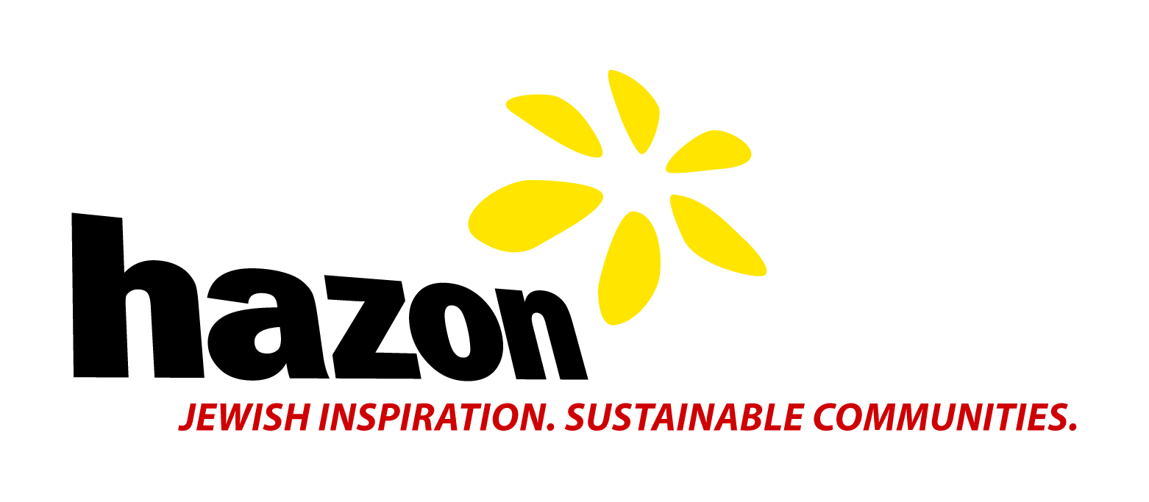
For Immediate Release
JEWISH CROSS-COUNTRY BIKE RIDE COMPLETED IN WASHINGTON DC – RIDING IN SUPPORT OF SUSTAINABLE FOOD SYSTEMS
40 Jewish cyclists ride 3,600 miles from Seattle, WA to Washington, DC
“The people of the book are now the people of the bike…”

Contact: Wendy Levine
Wendy.levine@hazon.org
212-644-2332 x332

August 20, 2012- On Wednesday, August 15th, 30 Jewish cyclists arrived in Washington, DC completing the last leg of the Hazon Cross-USA Ride. The ten-week journey began in Seattle, WA and is organized by Hazon, one of the leading faith-based environmental organizations in the country and a driving force behind the growth of the Jewish Food Movement. Founded in 2000 with a cross-country ride, Hazon aims to touch people’s lives directly; by building and strengthening institutions that create healthier, richer, and more sustainable Jewish communities. “The Jewish community has always cared about social justice – and we’ve always loved food,” explains Nigel Savage, Hazon’s founder and Executive Director, “People need to know how strongly many people in the Jewish community feel about sustainable food systems.”

These intrepid cyclists have raised over $150,000 in support of sustainable food systems from over 1200 donors. They visited 13 states, climbed the Rockies and the Appalachians, and crossed the Missouri, Mississippi, and Ohio Rivers. They biked in incredibly hot and humid conditions with headwinds not to be believed. They met farmers, policy makers, rabbis, and ordinary people sharing their stories and interactions with the USA’s food system. It’s no surprise that the most impactful piece of the journey was experiencing the system in action. Riders visited an ethanol plant, toured a grain elevator and windmill farm, spoke to USDA representatives, and volunteered at bike shops and soup kitchens, among others.

Riders marked the end of their journey in a variety of ways this past Wednesday, August 15th. They first ceremoniously dipped their bikes into the water, as they did in the beginning of their trip, at Georgetown Waterfront Park, then friends and family members greeted the riders as they crossed the finish line, together, in front of the White house.

Naomi Adland, 25 of Brooklyn, NY thought of this ride as something she never dreamed of accomplishing. “I did things I never thought I could do, including bike 88 miles in one day. I’ve made some amazing friends, biked some beautiful stretches of the country, and taken a much needed vacation. Though my body is tired, I feel mentally refreshed and re-energized.”

Jeremy Brochin, 65 of Philadelphia, PA was touched by the way the ride affected smaller Jewish communities. “We visited Jewish communities in Missoula, Helena, Bozeman, Billings, Spokane, Aberdeen, and the Twin Cities. We learned about these small communities including how they started and ways in which they are trying to maintain themselves. They greeted us with open arms and I think were energized by this Jewish group that was celebrating Jewish life, supporting environmental change, and cycling across the country.”

Serene Victor, 65 of Newton, MA, did the ride to celebrate her 65th birthday and recent retirement. “I am changing my understanding of what it means to be ’old.’ It is exhilarating to feel myself in motion, strong and healthy, capable of extraordinary deeds. Secondly, biking gives me the opportunity to coexist with the landscape rather than dominating it as one does in a car. When I am on my bike it matters which way the grass sways and leaves blow, the dust swirls and the clouds move and what that portends, and whether the horizon requires a climb or a descent. Even the debris on the side of the road tells a story. Finally, but certainly not least, I believe in Hazon's mission to create a sustainable way of life and provide opportunities for committed Jews to become active and engaged with the world beyond ourselves because of our obligation as Jews.”

For additional photos, videos and information about the end of the trip: http://www.hazon.org/3600-miles-and-10-weeks-later-the-hazon-cross-usa-ride-arrives-in-dc/

For all information about the ride: hazoncrossusa.tumblr.com www.hazon.org/crossusa

Hazon creates healthier and more sustainable communities in the Jewish world and beyond through transformative experiences, thought leadership, and capacity-building. In addition to bike rides, The Hazon Food Conference brings together foodies, educators, rabbis, farmers, nutritionists, chefs, food writers, and families who share a passion for learning about and celebrating food. The Hazon CSA Program is the first Jewish Community-Supported Agriculture (CSA) program in North America and is currently the largest faith-based CSA program in the country. In 2011, more than 55 Hazon CSAs put over $1.5 million in Jewish family purchasing power behind local, sustainable farms.
Links to our Photos:
http://www.hazon.org/wp-content/uploads/2011/06/panorama-all-riders.jpg
http://25.media.tumblr.com/tumblr_m8tda6dFjs1rtcy4qo1_1280.jpg
http://www.hazon.org/wp-content/uploads/2012/07/Bikers-with-Sunflower.jpg
http://www.hazon.org/wp-content/uploads/2012/08/jon-wood.jpg
http://www.hazon.org/wp-content/uploads/2012/06/1.-Hazon-Cross-USA-Ride-participants-begin-a-day-of-cycling.png

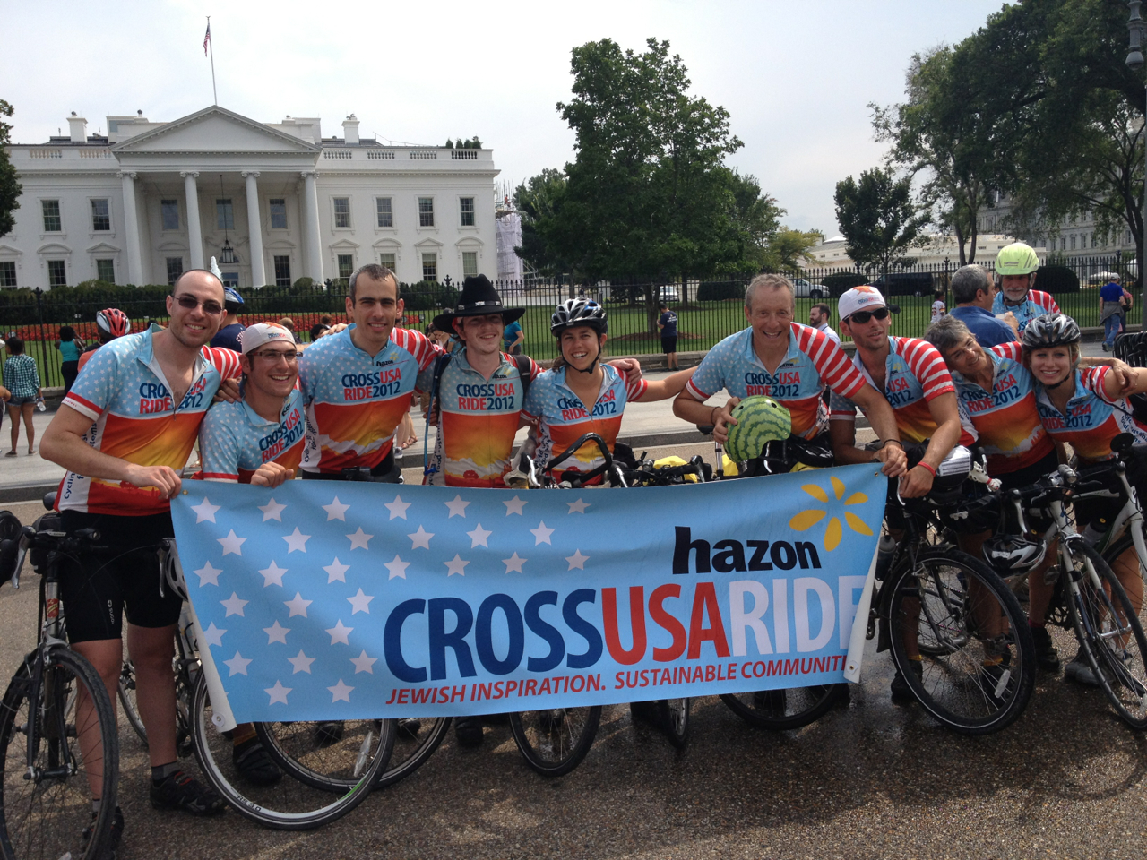

Full Country riders

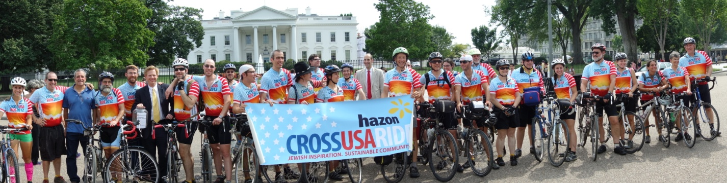
All the riders in front of the White house

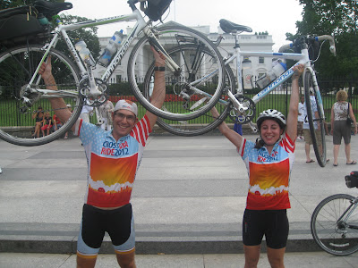
Adi and Danielle holding up their bikes in front of the White House at the end of the ride

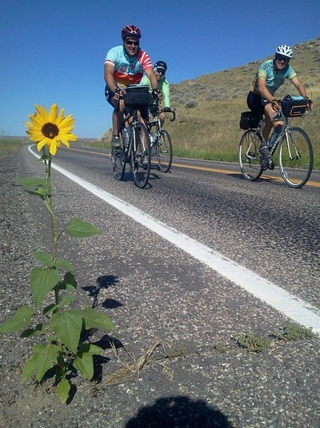
The riders in Montana

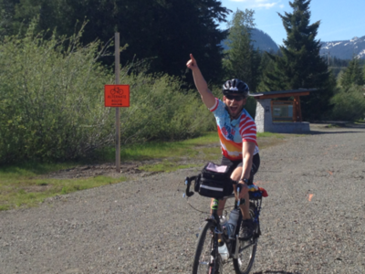
Jon Wood after a 2-mile tunnel in Washington State

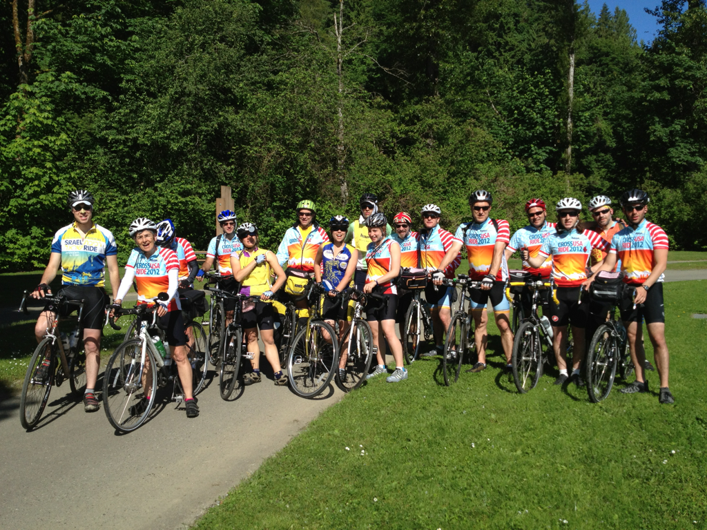
Hazon Cross-USA riders begin a day of cycling

